Agenda- Generate/Download PDF and then attach it to the Case

To do this we need to create one case type and then we need to create 2 collect information step one for capturing the information and the second step is for downloading

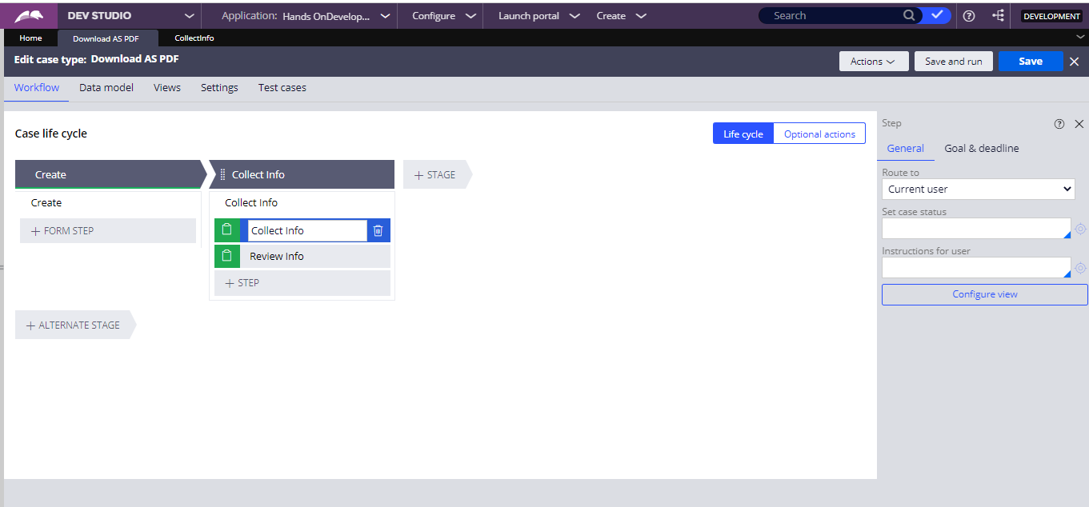

And in the first step under the section give the properties with the required fields.

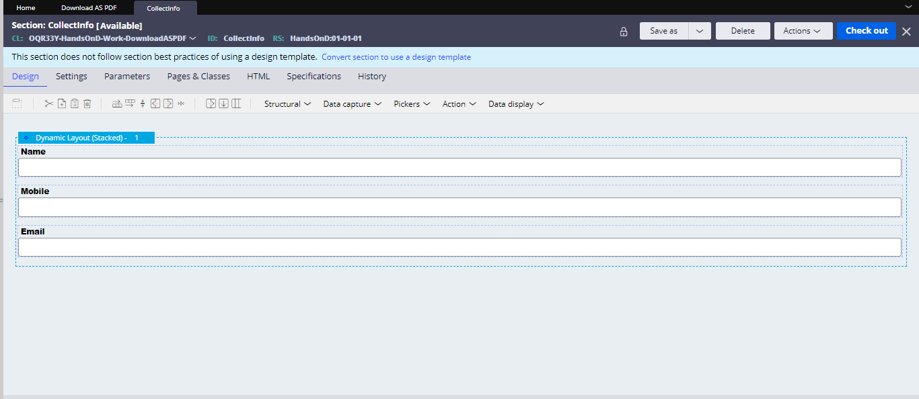

And then in the second section use one button

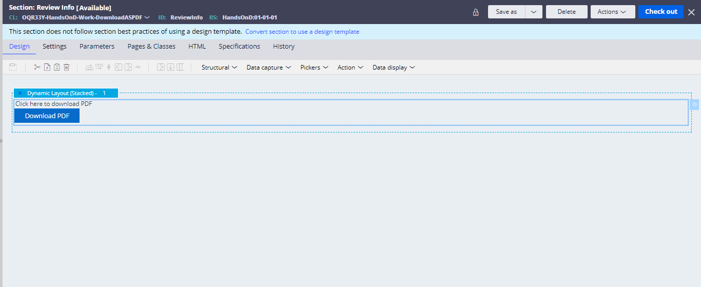

And then use an activity to generate the PDF and download

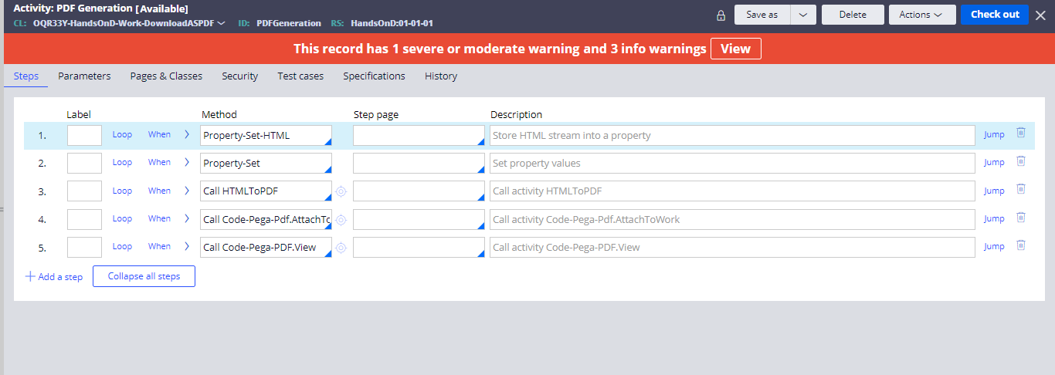

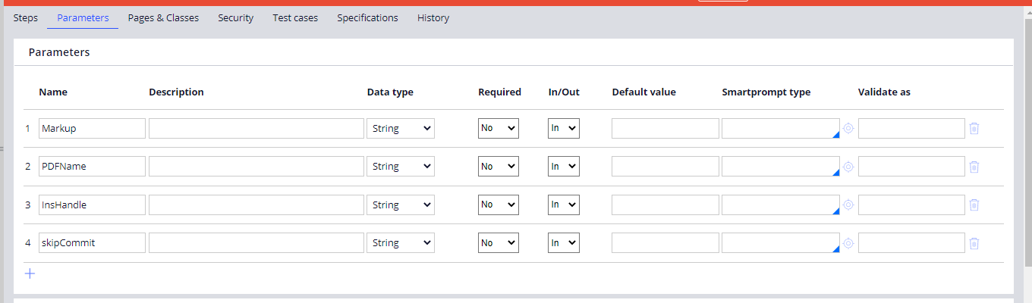

And in the first step Property-set-html we need to give the html where we would be writing the custom HTML to show in the PDF and also to call the section of the previous information

And then we need to give the following code

<!DOCTYPE html>

<html>

<body>

<h1>Welcome To PegaPOC<h1>

<h2>Example for PDF Generation</h2>

</body>

</html>

<pega:include name="CollectInfo" type="Rule-HTML-Section"/>

So in the code the html tags and headings are common just the the last step is that you are including the section of the particular flow

And the type is obviously Rule-HTML-Section

And then we have to add it in the step Property-set-HTML

And in the second step

Add the parameters for the PDFName and InsHandle and skipCommit.

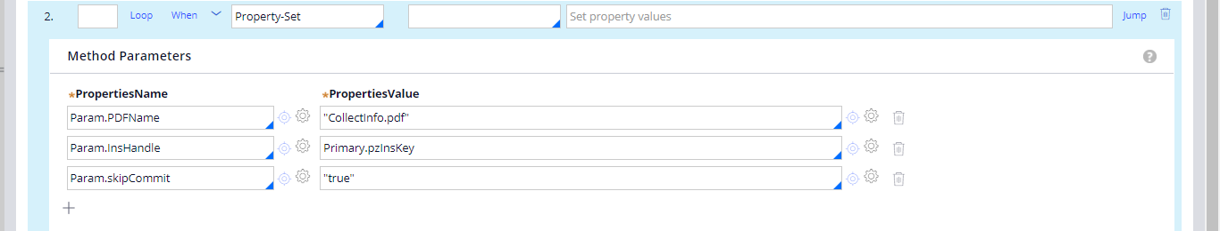

And now go call the HTML to PDF and use pass current parameter page since you declared it as the property- set

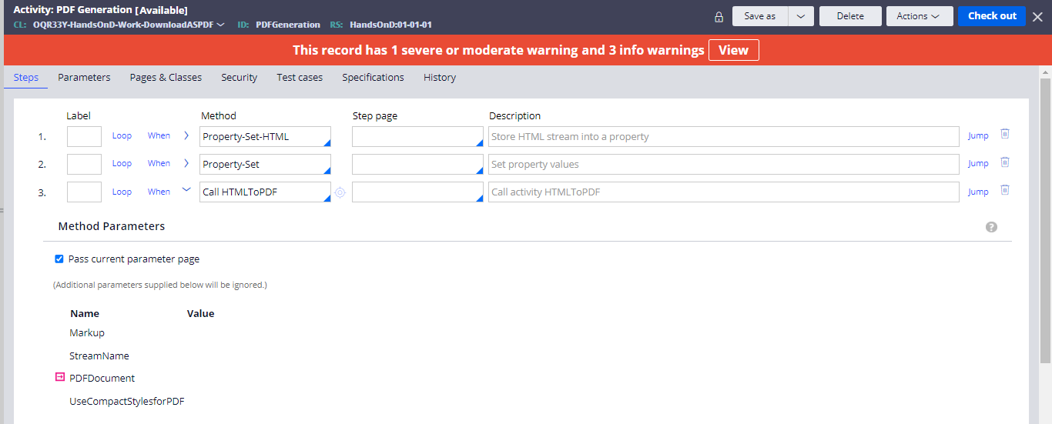

And then use one more method as the class Code-Pega-Pdf.AttachToWork

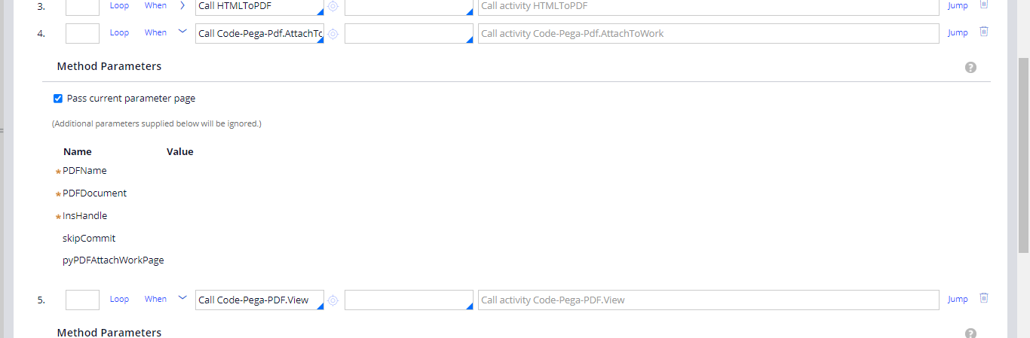

And pass current parameter page and then use again Code-Pega-PDF.view and then do the 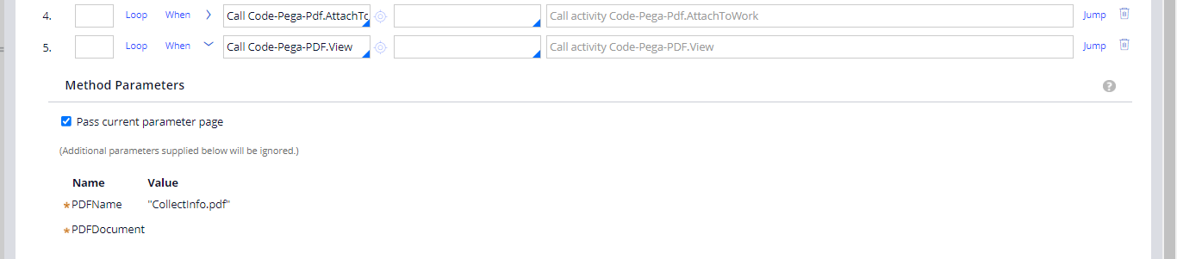

And then use Pass current parameter page and save the activity and pass it on the button action set

And use display refresh

And then create a case

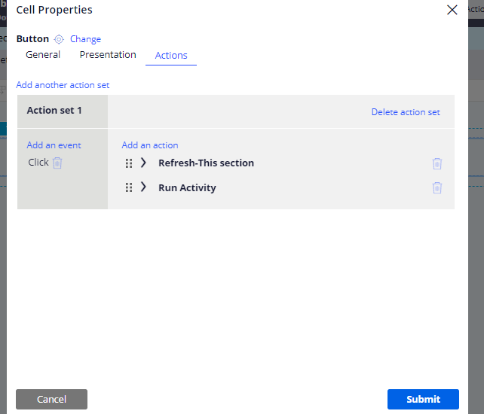

And after that when the case is created

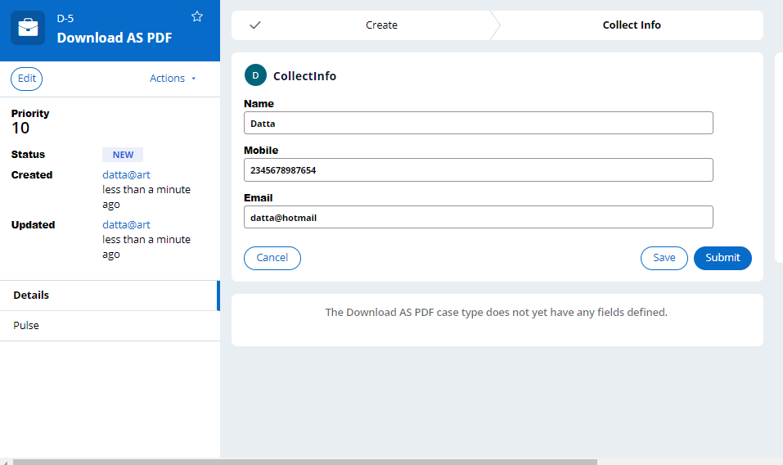

And then submit and then click on download

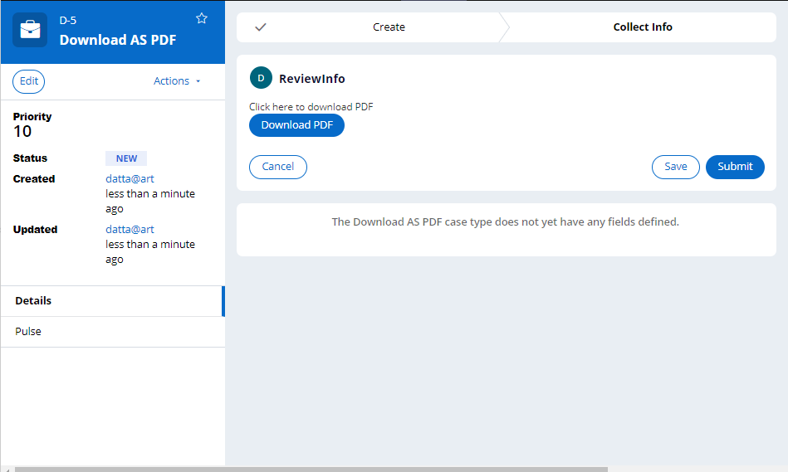

And then pdf will look like this

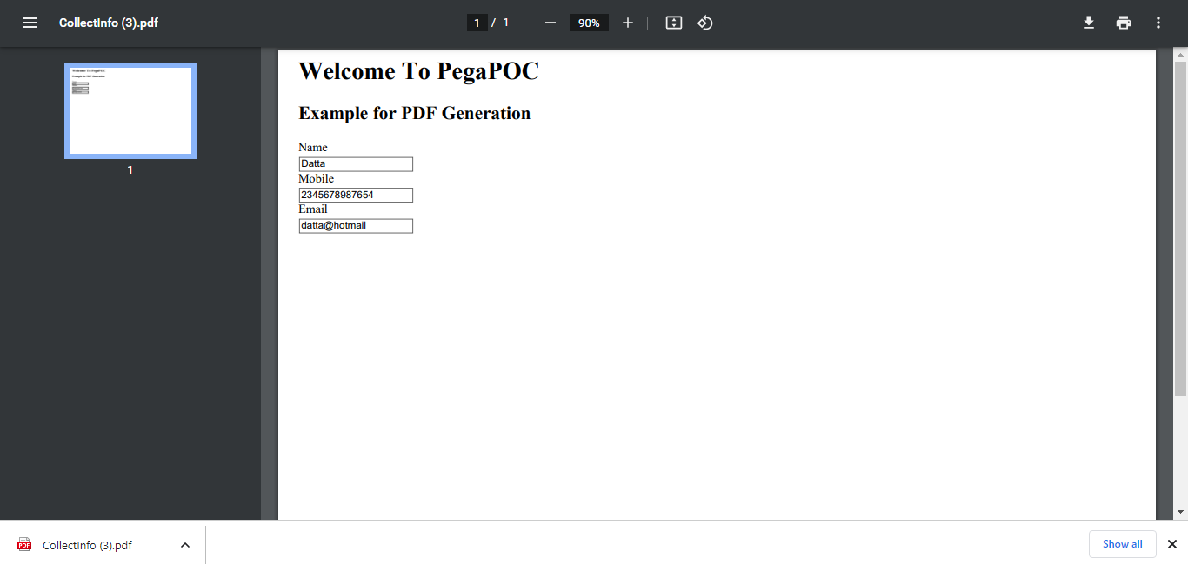

That’s it